**Bug Report – bhaane**

|  |  |  |
| --- | --- | --- |
| **Bug#** | **Description** | **Severity** |
| TU1-I2 | 'Thank you for registering' email is not received to the registered email address after registering an account | Minor |
| TU1-I3 | 'Privacy Policy' Checkbox field in 'Register Account' page is not Present. | Minor |
| TU1-I4 | ‘Contact field will be accept space in between numbers’. | Minor |
| TU1-I5 | 'Telephone' field in 'Register Account' page is accepting the spaces and not showing warning message | Minor |
| TU1-I6 | Markdown section contain the Size of the Product in ‘ some of the size don’t contain the any product ‘ it not show any ‘out of stack’ message. | Major |
| TU1-I7 | Leading and Trailing spaces are accepted by the text fields in the 'Register Account' page | Minor |
| TU1-I8 | User is getting logged in automatically on browsing back immediately after logout | Major |
| TU1-I9 | User is not automatically getting logged out of the Application after 30 minutes of inactivity | Major |
| TU1-I10 | User is not getting logged out in one browser, when logged out in another browser | Minor |
| TU1-I11 | Email address is not getting carry forwarded from the 'Login' page to 'Forgot Your Password' page | Minor |
| TU1-I12 | Using tab keyboard key is not highlighting the 'Search in subcategories' checkbox field | Minor |
| TU1-I13 | ‘Buy now and quantity option’ not present in the any of product. | Major |
| TU1-I14 | There is no activity down by ‘Size’ button present in the others Section . | Minor |
| TU1-I15 | Subscription field after entering of the valid information click the submit the covering with some unexpected Colour it not show any Pop like ‘ Subscription is down’ | Critical |
| TU1-I16 | Logo of the Application is missing, instead 'Your Text' is getting displayed | Minor |
| TU1-I17 | Some of Footer functionalities are Navigate to new tab. | Minor |
| TU1-I18 | Search operation show invalid output if item is not present then also shown wrong . | Minor |

|  |  |
| --- | --- |
| Bug Id | TU1-I2 |

|  |  |
| --- | --- |
| Brief Summary | 'Thank you for registering' email is not received to the registered email address after registering an account |

|  |  |
| --- | --- |
| Severity | Minor |

|  |
| --- |
| Steps to Reproduce |

1. Open the Application URL

2. Click on 'Account' menu

3. Select 'Register/Sign up' option

4. Enter the new User valid details into the 'Register Account' page

5. Click on ‘Submit’ button

**Expected Result:**

User Account should be created and an email with the subject 'Thank you for registering' should be received by the registered email address.

**Actual Result:**

User Account is getting created, but the email with subject 'Thank you for registering' is not received to the registered email address.

|  |
| --- |
| Screenshot |

Not Applicable

Top

|  |  |
| --- | --- |
| Bug Id | TU1-I3 |

|  |  |
| --- | --- |
| Brief Summary | 'Privacy Policy' Checkbox field in 'Register Account' page is not Present. |

|  |  |
| --- | --- |
| Severity | Minor |

|  |
| --- |
| Steps to Reproduce |

1. Open the Application URL

2. Click on 'Account' menu

3. Select 'Register/Sign up' option

4. Enter valid details into the fields displayed on the 'Register Account' page

5. Select 'Privacy Policy' checkbox field.

**Expected Result:**

Expect Presence of 'Privacy Policy' checkbox.

**Actual Result:**

'Privacy Policy' checkbox is absent.

|  |
| --- |
| Screenshot |

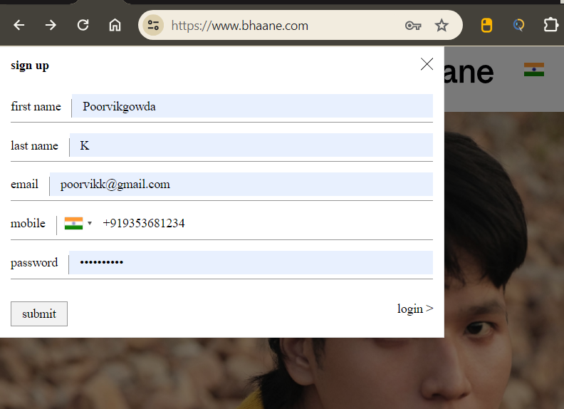

Top

|  |  |
| --- | --- |
| Bug Id | TU1-I4 |

|  |  |
| --- | --- |
| Brief Summary | ‘Contact field will be accept space in between mobile number digits’. |

|  |  |
| --- | --- |
| Severity | Minor |

|  |
| --- |
| Steps to Reproduce |

1. Open the Application URL in any browser

2. Click on 'Account' menu

3. Select 'Register/Sign up' option

4. Enter the space between numbers in the mobile number field.

**Expected Result:**

Show the warning message like “invalid format of mobile number”.

**Actual Result:**

It allows the spaces between mobile number.

|  |
| --- |
| Screenshot |

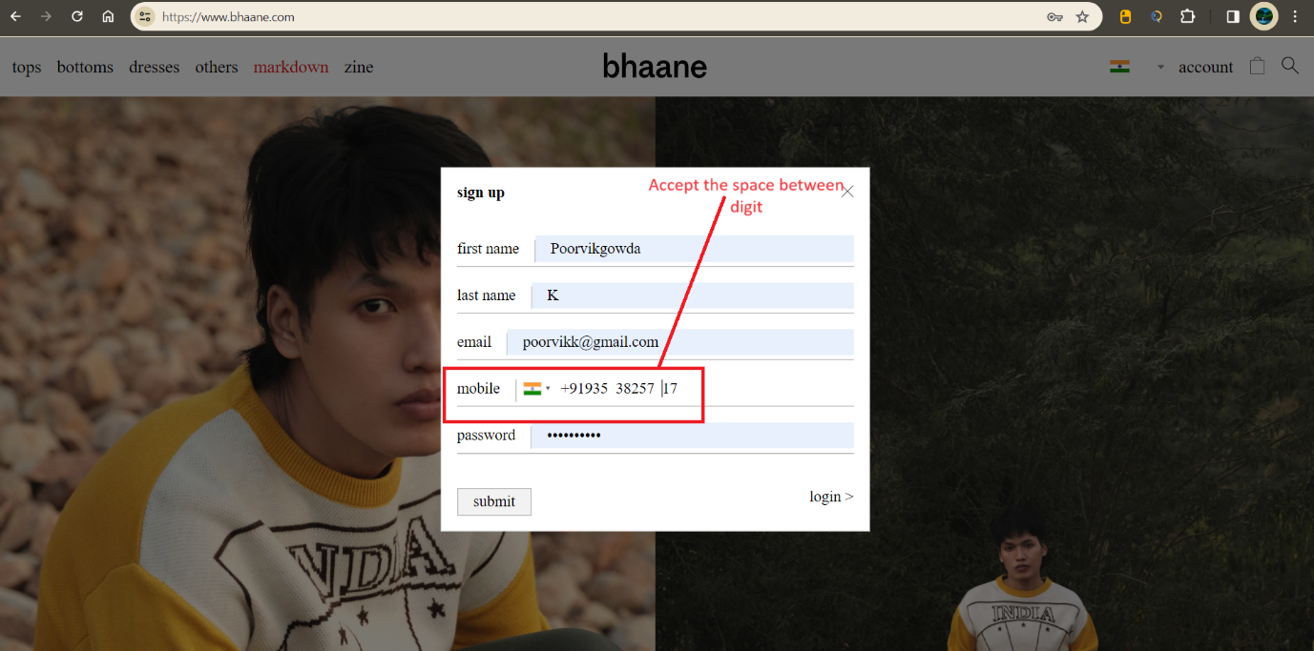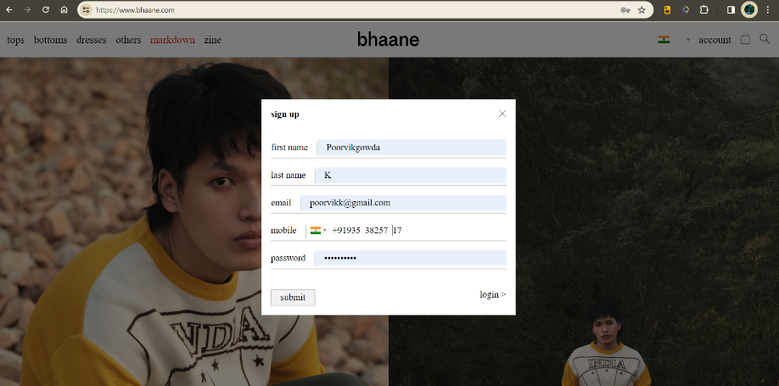

Top

|  |  |
| --- | --- |
| Bug Id | TU1-I5 |

|  |  |
| --- | --- |
| Brief Summary | 'Telephone' field in 'Sign up’ page is accepting the spaces and not showing warning message |

|  |  |
| --- | --- |
| Severity | Minor |

|  |
| --- |
| Steps to Reproduce |

1. Open the Application URL in any browser
2. Click on 'My Account' dropmenu
3. Selection 'Register' option
4. Enter spaces into all the mandatory fields including ‘Mobile’ field
5. Click on ‘Submit’ button

**Expected Result:**

Warning message informing the User to enter the Telephone field should be displayed

**Actual Result:**

Telephone field is accepting the spaces and no field level warning message is displayed for this field.

|  |
| --- |
| Screenshot |

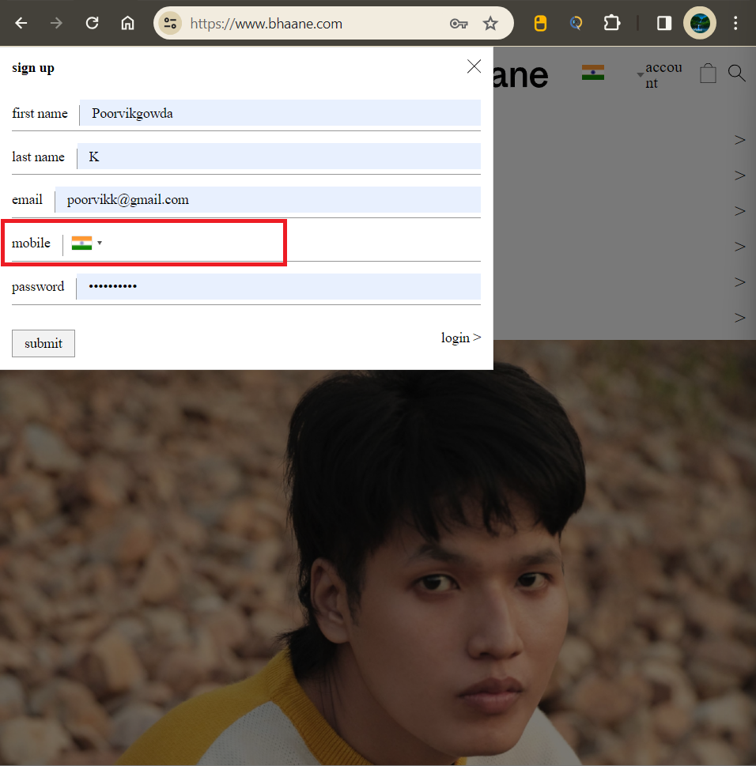

Top

|  |  |
| --- | --- |
| Bug Id | TU1-I6 |

|  |  |
| --- | --- |
| Brief Summary | Markdown section contain the Size of the Product in ‘ some of the size don’t contain the any product ‘ it not show any ‘out of stack’ message |

|  |  |
| --- | --- |
| Severity | Minor |

|  |
| --- |
| Steps to Reproduce |

1. Open the Application URL in any browser
2. Click on 'Account' Menu
3. Click the Markdown button.
4. In Mark down section the select the Items by size.

**Expected Result:**

Show the Product or ‘Show the out of Stack pop up message.

**Actual Result:**

There is no any pop up shown it show Blanck page

|  |
| --- |
| Screenshot |

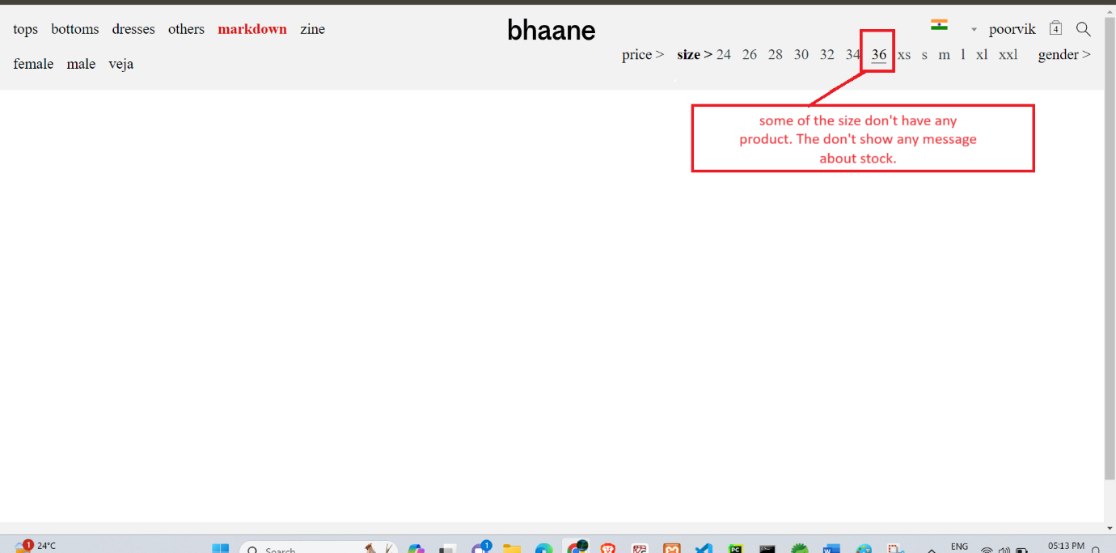

Top

|  |  |
| --- | --- |
| Bug Id | TU1-I7 |

|  |  |
| --- | --- |
| Brief Summary | Leading and Trailing spaces are accepted by the text fields in the 'Register Account' page |

|  |  |
| --- | --- |
| Severity | Minor |

|  |
| --- |
| Steps to Reproduce |

1. Open the Application URL in any browser
2. Click on 'Account' Menu
3. Select 'Register' option
4. Enter leading and trailing spaces to the text fields in the 'Register Account' page
5. Select 'Privacy Policy' checkbox field
6. Click on 'Continue' button

**Expected Result:**

Leading and Trailing spaces should not be accepted by the text fields in the 'Register Account' page

**Actual Result:**

Leading and Trailing spaces are accepted by the text fields in the 'Register Account' page and account is getting created.

|  |
| --- |
| Screenshot |

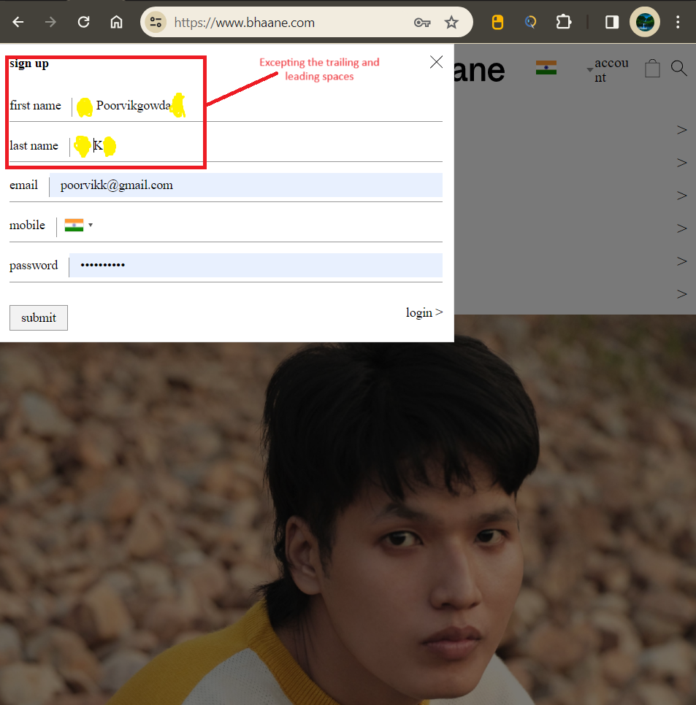

Top

|  |  |
| --- | --- |
| Bug Id | TU1-I8 |

|  |  |
| --- | --- |
| Brief Summary | User is getting logged in automatically on browsing back immediately after logout |

|  |  |
| --- | --- |
| Severity | Minor |

|  |
| --- |
| Steps to Reproduce |

1. Login to the Application
2. Click on ‘Account' menu
3. Select 'Logout' option
4. Click on browser back button

**Expected Result**

User should not get logged in automatically

**Actual Result**

User is getting logged in automatically

|  |
| --- |
| Screenshot |

Not Applicable

Top

|  |  |
| --- | --- |
| Bug Id | TU1-I9 |

|  |  |
| --- | --- |
| Brief Summary | User is not automatically getting logged out of the Application after 30 minutes of inactivity |

|  |  |
| --- | --- |
| Severity | Major |

|  |
| --- |
| Steps to Reproduce |

1. Login to the Application with valid credentials
2. Don't perform any action for next 30 minutes
3. Try to perform any action after the above 30 minutes like Search a product etc.

**Expected Result:**

User should get automatically logged out

**Actual Result:**

User is not getting logged out

|  |
| --- |
| Screenshot |

Not Applicable

Top

|  |  |
| --- | --- |
| Bug Id | TU1-I10 |

|  |  |
| --- | --- |
| Brief Summary | User is not getting logged out in one browser, when logged out in another browser |

|  |  |
| --- | --- |
| Severity | Minor |

|  |
| --- |
| Steps to Reproduce |

1. Login to the Application with same credentials in Chrome and Firefox Browser
2. Logout in Chrome browser
3. Check performing any action in Firefox browser

**Expected Result**

User should also get logged out in Firefox browser

**Actual Result**

User is not getting logged out automatically in Firefox browser

|  |
| --- |
| Screenshot |

Not Applicable

Top

|  |  |
| --- | --- |
| Bug Id | TU1-I11 |
|  |  |

|  |  |
| --- | --- |
| Brief Summary | Email address is not getting carry forwarded from the 'Login' page to 'Forgot Your Password' page |

|  |  |
| --- | --- |
| Severity | Minor |

|  |
| --- |
| Steps to Reproduce |

1. Open Application URL
2. Click on 'My Account' dropmenu
3. Select 'Login' option
4. Enter email address into the 'E-Mail Address' text field
5. Click on 'Forgotten Password' link

**Expected Result:**

Email address given in Login page should get carry forwarded to 'Forgot Your Password' page

**Actual Result:**

Email address given in Login page is not getting carry forwarded to 'Forgot Your Password' page

|  |
| --- |
| Screenshot |

Not Applicable

Top

|  |  |
| --- | --- |
| Bug Id | TU1-I12 |

|  |  |
| --- | --- |
| Brief Summary | Using tab keyboard key is not highlighting the 'Search in subcategories' checkbox field |

|  |  |
| --- | --- |
| Severity | Minor |

|  |
| --- |
| Steps to Reproduce |

1. Open Application URL
2. Click on 'Search' icon without entering any product name
3. In the displayed 'Search' page, continuously press 'Tab' keyboard key

Expected Result:

All the options on the 'Search' page should get highlighted/focused.

Actual Result:

'Search in subcategories' field is not highlighted or focused.

|  |
| --- |
| Screenshot |

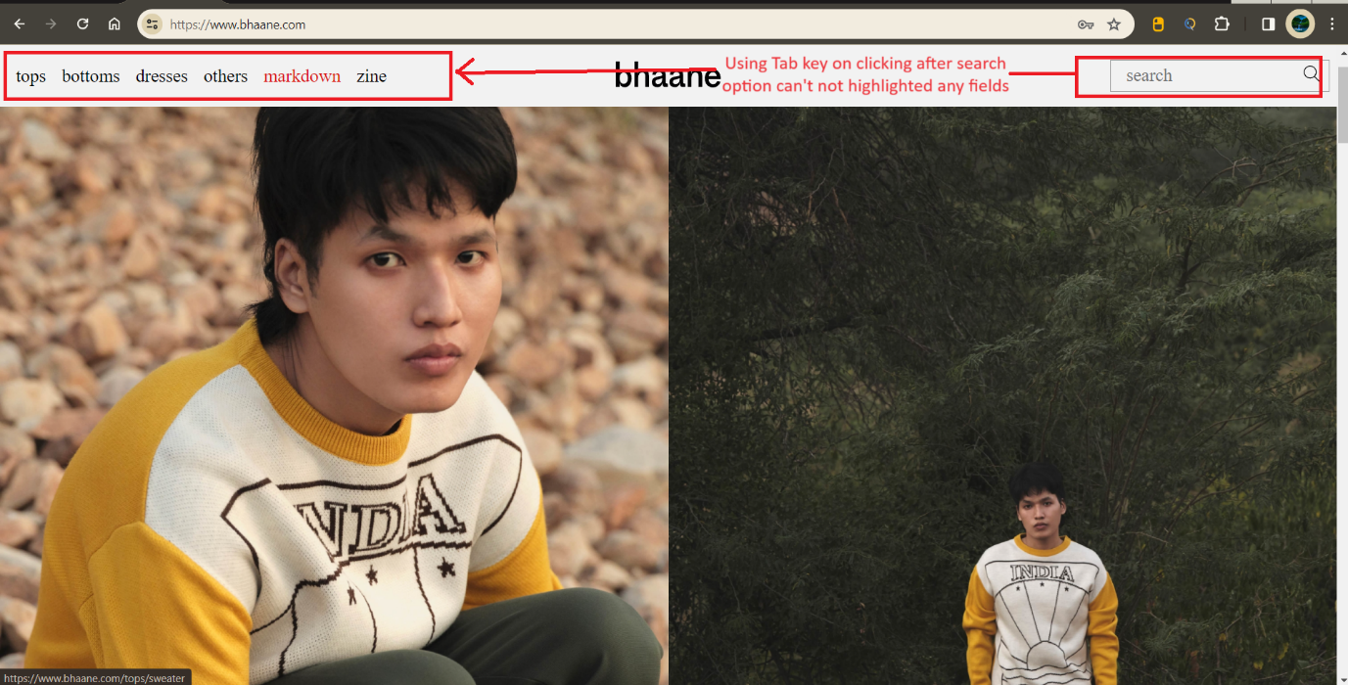

Top

|  |  |
| --- | --- |
| Bug Id | TU1-I13 |

|  |  |
| --- | --- |
| Brief Summary | ‘Buy now and quantity option’ not present in the any of product. |

|  |  |
| --- | --- |
| Severity | Major |

|  |
| --- |
| Steps to Reproduce |

1. Open Application URL
2. Enter any Product
3. Try to Buy the product or Add the quantity of product you need.

**Expected Result**

User should be able to add Quantity of product and Buy option on product

**Actual Result**

In our shopping products not have add quantity and Bye options are not getting displayed

|  |
| --- |
| Screenshot |

Not Applicable

Top

|  |  |
| --- | --- |
| Bug Id | TU1-I14 |

|  |  |
| --- | --- |
| Brief Summary | There is no activity down by ‘Size’ button present in the others Section . |

|  |  |
| --- | --- |
| Severity | Mainor |

|  |
| --- |
| Steps to Reproduce |

1. Login to the Account having few orders placed
2. Clicking on the Product section.
3. Select the Other Section.
4. Click the ‘Size’ Button present in top right side of the Page

**Expected Result**

User Expect the Products sorting by their Size ascending or descending order.

**Actual Result**

Button not Perform any action.

|  |
| --- |
| Screenshot |

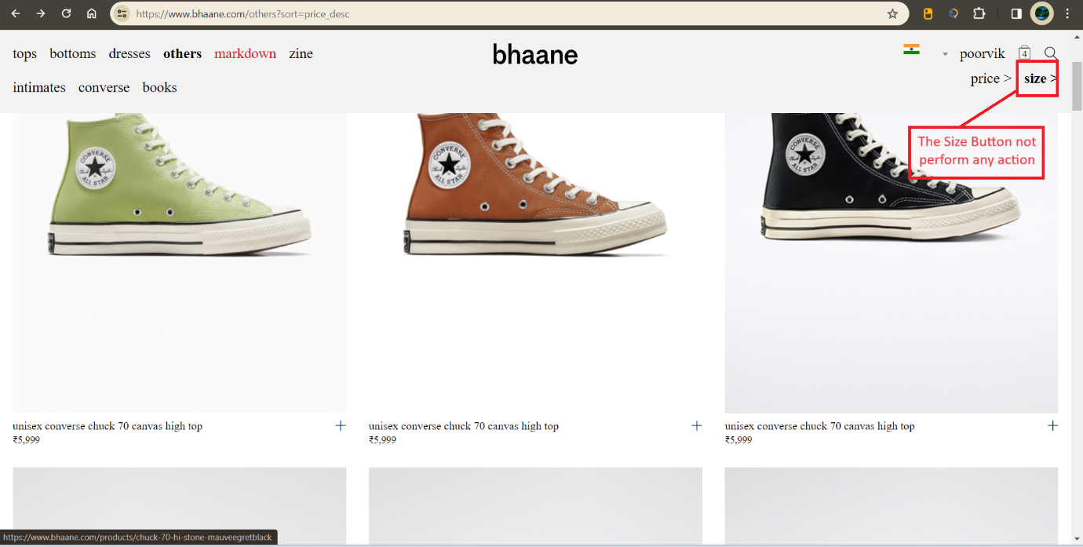

Top

|  |  |
| --- | --- |
| Bug Id | TU1-I15 |

|  |  |
| --- | --- |
| Brief Summary | Subscription field after entering of the valid information click the submit the covering with some unexpected Colour it not show any Pop like ‘ Subscription is down’ |

|  |  |
| --- | --- |
| Severity | Critical. |

|  |
| --- |
| Steps to Reproduce |

1. Open Application URL
2. Click on Subscription fill valid data Click Sign up.

Expected Result

Display the Proper Message Like ‘Subscription is Down’.

Actual Result

Show the unwanted black mark on the provided information.

|  |
| --- |
| Screenshot |

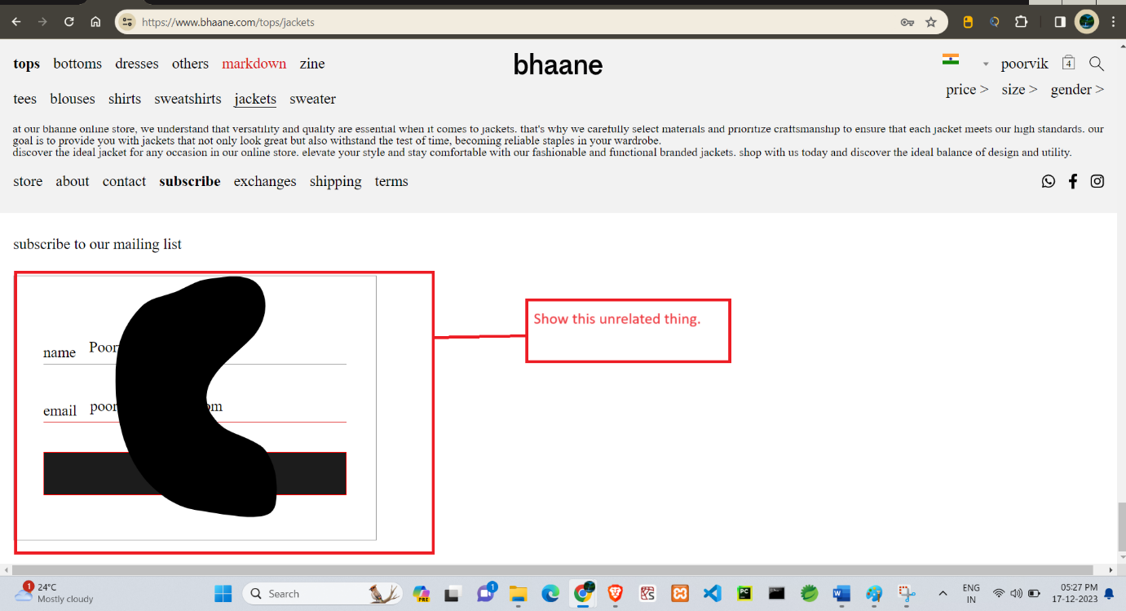

Top

|  |  |
| --- | --- |
| Bug Id | TU1-I6 |

|  |  |
| --- | --- |
| Brief Summary | Logo of the Application is missing, instead 'Your Text' is getting displayed |

|  |  |
| --- | --- |
| Severity | Minor |

|  |
| --- |
| Steps to Reproduce |

1. Open Application URL

**Expected Result**

Logo should be displayed on the top left of the page

**Actual Result**

Logo is not getting displayed, instead 'Your Text' is displayed on the page as shown in the attached screenshot

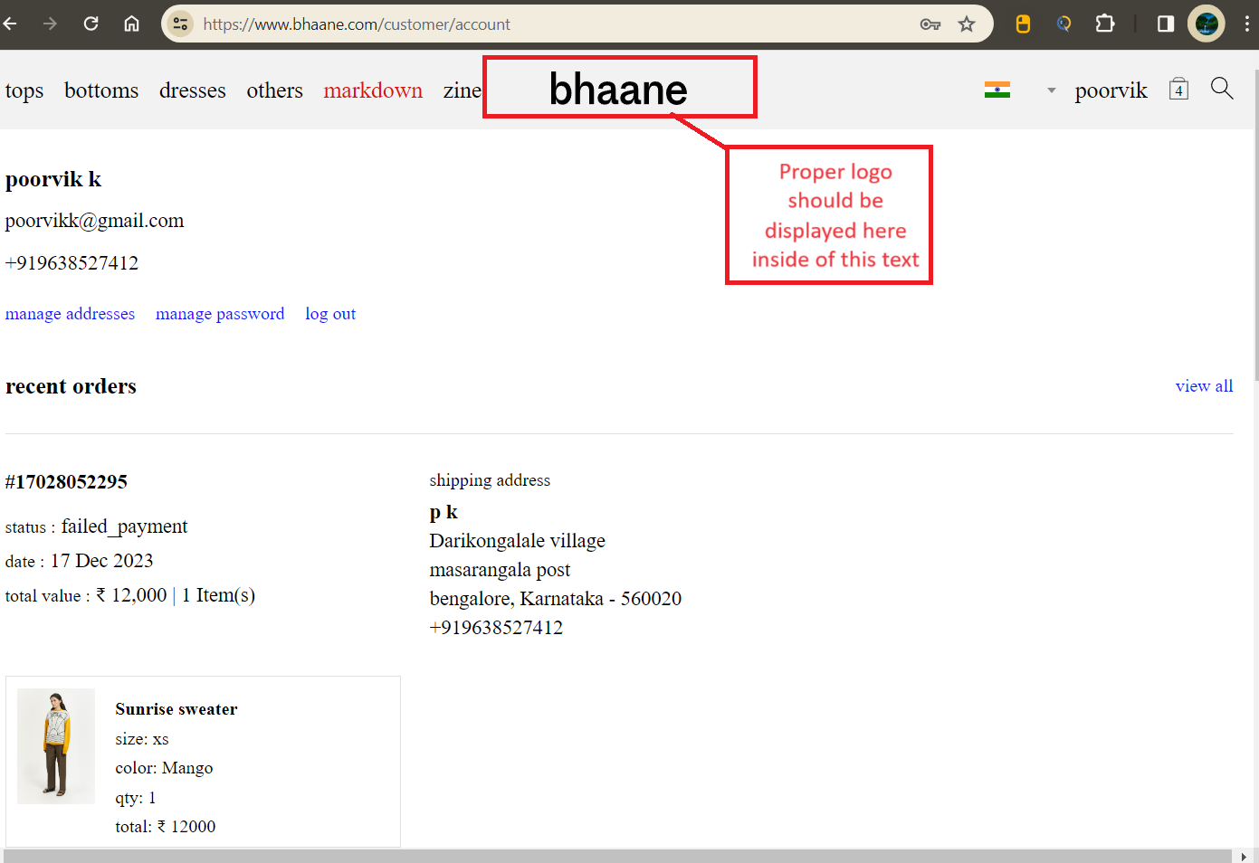

|  |
| --- |
| Screenshot |

Top

|  |  |
| --- | --- |
| Bug Id | TU1-I17 |

|  |  |
| --- | --- |
| Brief Summary | Some of Footer functionalities are Navigate to new tab. |

|  |  |
| --- | --- |
| Severity | Minor |

|  |
| --- |
| Steps to Reproduce |

1. Open Application URL
2. Go to footer section click the section present they navigate to new tab.

**Expected Result**

All information will be displayed in same page.

**Actual Result**

Some functionalities are navigate to new tab the not support to came back to the actual page.

|  |
| --- |
| Screenshot |

Not Applicable

Top

|  |  |
| --- | --- |
| Bug Id | TU1-I18 |

|  |  |
| --- | --- |
| Brief Summary | Search operation show invalid output if item is not present then also show the message like “Showing search results for "sfaaafeds" > |

|  |  |
| --- | --- |
| Severity | Minor |

|  |
| --- |
| Steps to Reproduce |

1. Open Application URL
2. Click login.
3. Click on search option.
4. Fill the Search option with item name and click enter.
5. Search the product if the product is not available then also show Showing search results for "enter product name" .

**Expected Result**

Out of stock or No results for ‘sfaaafeds’,Try checking your spelling or use more general terms.

**Actual Result**

Showing search results for " sfaaafeds " >

|  |
| --- |
| Screenshot |

Not Applicable

Top